CS LAB ASSIGNMENT 1

Abdul Moiz, 474550, Sec B, ME-15

// TASK 1

#include <iostream>

using namespace std;

int main() {

int x;

x = 6;

x = (x) \* (x - 1) \* (x - 2) \* ( x - 3) \* ( x - 4) \* ( x - 5);

cout << "The factorial of 6 is " << x;

return 0;

}

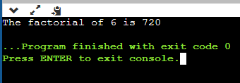

// TASK 2

#include <iostream>

#include <cmath>

using namespace std;

int main(){

int x1, x2, y1, y2;

cout << "Enter the coordinates of point 1 "<< endl;

cin >> x1;

cin >> y1;

cout << "Enter the coordinates of point 2 "<< endl;

cin >> x2;

cin >> y2;

double dist;

dist = sqrt ((pow((x2-x1), 2))+(pow((y2-y1), 2)));

cout << "The distance between them is " << dist;

return 0;

}

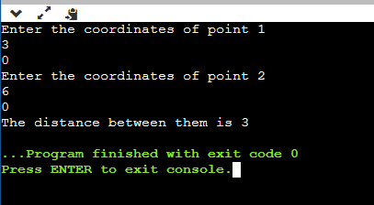

// TASK 3

#include <iostream>

using namespace std;

int main(){

double cm, m, km;

cout << "Insert length in centimetres, we'll convert into metres and kilometres: ";

cin >> cm;

m = cm / 100;

km = m / 1000;

cout << "It is " << m << " metres and " << km << " kilometres.";

return 0;

}

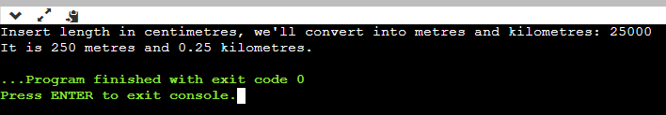

// TASK 4

#include <iostream>

#include <cmath>

using namespace std;

int main(){

double a,b;

cout << "Enter two values for a and b: "<< endl;

cin >> a;

cin >> b;

double answer;

answer = pow(a, 2) + ( 2 \* a \* b) + pow(b , 2);

cout << "The answer is " << answer;

return 0;

}

